Fast and furious Goal Attack and Shooting specialist Sasha Glasgow turned to West Coast Fever for the 2021 season from the Adelaide Thunderbirds.

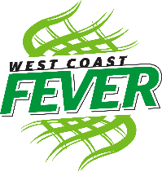
Sasha Glasgow was born in Moonta South Australia and has grown to be a shocking 6’2. She has been enrolled into the University of South Australia before she joined West Coast Fever, she has been playing with Adelaide thunderbirds since 2017 all the way to 2020.

In the year 2008 Perth Orioles became the well-known West Coast Fever. Perth Orioles were formed to compete in the commonwealth bank trophy which was the major competition from 1997-2007. West coast fever consists of 11 powerful women all early to late twenties who together have won 8 games so far this season.

