STRESS FREE JOURNAL
Name:

Wellbeing – Stress
Sometimes life can move kinda fast, yk you have chill sometimes and take time for yourself x. This journal will help you deal with the craze of life.
Don’t worry many people also suffer from this and you’re not alone .
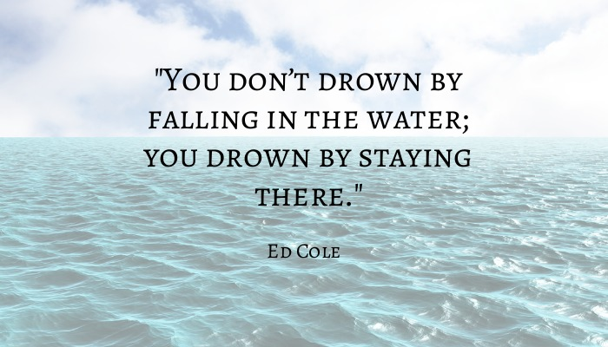

Colouring in
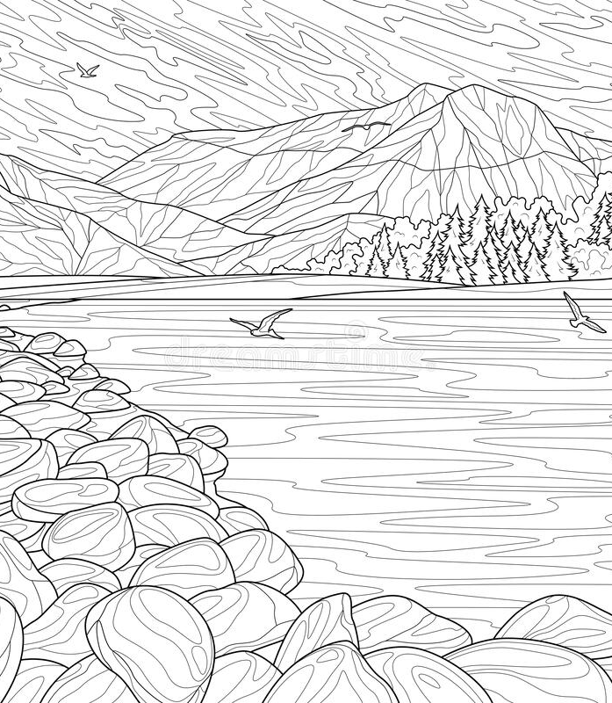

Brain Dump
________________________________________________________________________________________________________________________________________________________________________________________________________________________________________________________________________________________________________________________________________________________________________________________________________________________________________________________________________________________________________________________________________________________________________________________________________________________________________________________________________________________________________________________________________________________________________________________________________________________________________________________________________________________________________________________________________________________________________________________________________________________________________
Gratitude
What is something in your life that you love doing, but don't get to do as much as you would like?
__________________________________________________________________________________________________________________________________________________________________________________________________________________________________________________________

What are some things that you’re grateful for?
__________________________________________________________________________________________________________________________________________________________________________________________________________________________________________________________

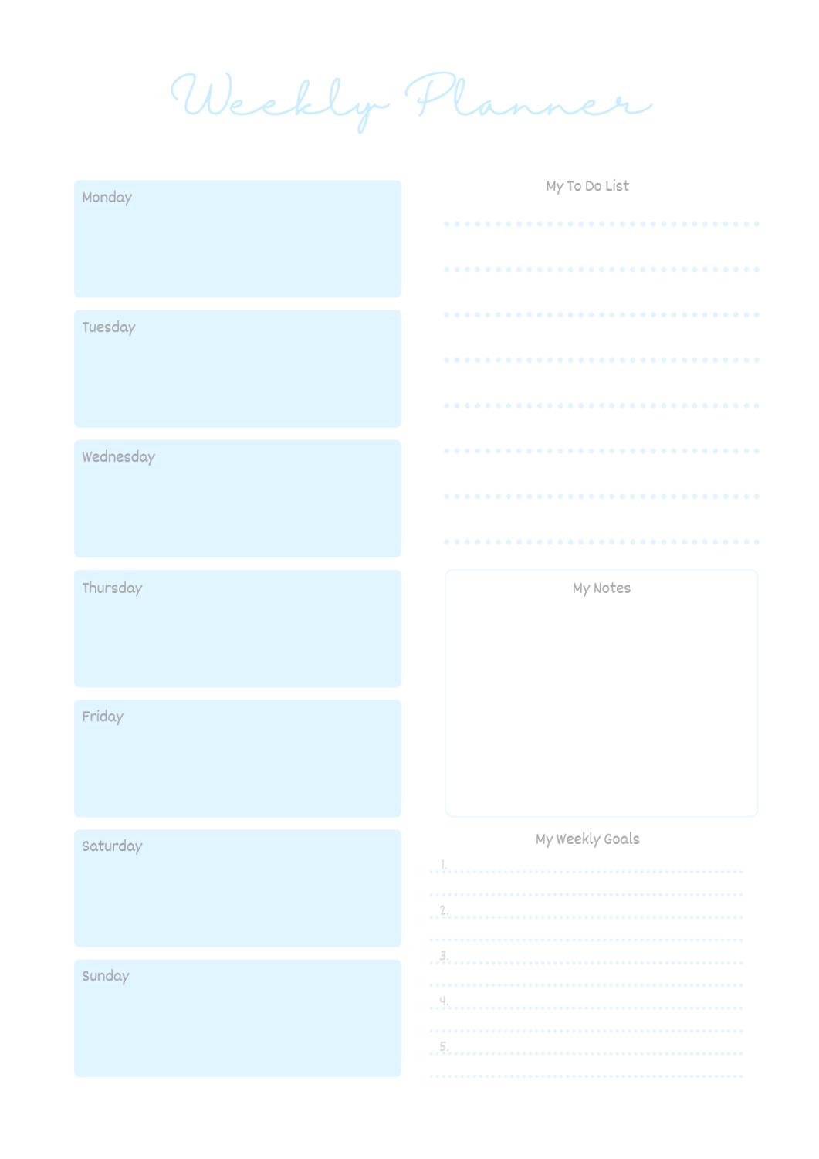

Relief page
If you are very stressed use this page to write down all the things that you can control and all the things out of your control.
- _________________________________________
- _________________________________________
- _________________________________________
- _________________________________________
- _________________________________________
Now, what can you do to change that and make you feel less stressed?
____________________________________________________________________________________________________________________________________________________________________________________________________________________________________________________________________________________________________________

Hopefully you feel better now.
Scribble Page
Instructions? There are none.

Gratitude
What items/objects/people do you find provide you with the most comfort in your life? List two of them below and describe why it brings you so much comfort.
________________________________________________________________________________________________________________________________________________________________________________________
______________________________________________

What happened in the past week that made you smile?
__________________________________________________________________________________________________________________________________________________________________________________________________________________________________________________________
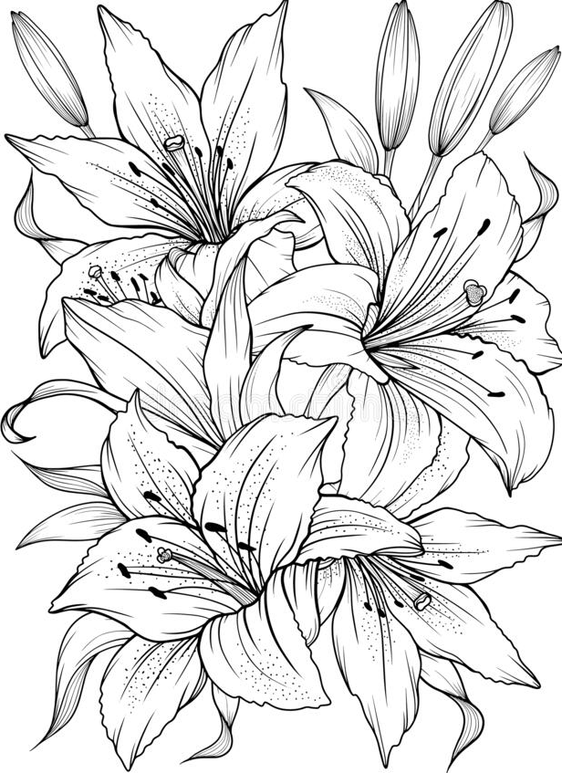
Colouring in

