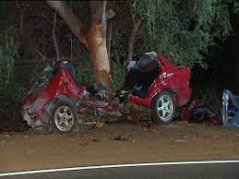
Don’t drink and drive, else you wont survive

42 people die every year from alcohol related car crashes in wa alone

On average 23% of fatal car crashes are alcohol related

Strategies against it: have an uber account, don’t drink, don’t drive.

