**Jamie Matthew Snow**

Perth  Western Australia t: +61 476219540 email: jamiemsnow@icloud.com

4/12/2006

**PROFILE**

**I am an enthusiastic, conscientious young learner who enjoys collaborating with others to achieve common goals. I have experience in many aspects of leadership, and I enjoy helping and coaching others. I am resilient under pressure and have experience in leading teams through challenging situations. I am highly motivated to achieve my goals, thrive on challenges and make the most of the opportunities given to me.**

**ACHIEVEMENTS/SKILLS**

* Australian Scout Medallion- (2021)
* Certificate II in Business
* Junior first-degree black belt (Mixed martial Arts)
* PADI Open Water Diver 2020
* Coaches Award - All Saints Rowing Team 2021
* Scouts Leadership and Skills Courses
* Coxswains Sailing Permit
* Numerous Academic Awards
* Service Representative (2019-2020)
* 2021 School House Counsellor
* Undertaking Duke of Edinburgh Award (Bronze)
* Robotics Robocup competitor (2018-2021)
* Robotics Robocup Nationals 3rd place (2021)



**EDUCATION: All Saints’ College- 2015 to Present**

**Completed Year 9**

**Experience in Entrepreneurship and Creativity:**

* **Certificate II in Business**
* Innovate Ed
* E-Portfolio - <http://portfolio.ascollege.wa.edu.au/jamie.snow/>

**WORK EXPERIENCE:**

* Lab Technician with Genotyping Australia – General assistant (School Holiday Work)
* All Saints’ College – Tech Coach

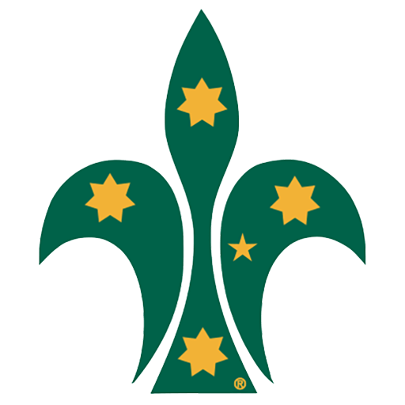**VOLUNTEER WORK:**

* Red Cross cooking for the homeless
* All Saints parish food drive
* Rotary Jacaranda festival scout volunteer work
* Bunnings Warehouse volunteer work- Scouts Australia
* ANZAC Day Ceremony- Scouting Support

**LEADERSHIP AND COLLABORATION:** 

* Patrol Leader - Scouts Australia
* 2021 School House Counsellor- All Saints College
* Mixed Martial Arts Junior Instructor 2019/2020
* Currently undertaking Duke of Edinburgh’s Award (Bronze)

**HOBBIES:**

* I have been a dedicated Sea Scout for eight years. I also enjoy spending time outdoors participating in a range of activities including rowing, fishing, camping, diving, snorkeling, water skiing, sailing and hiking. I also enjoy giving back to the community through the Scouting Association. I spend my spare time maintaining my reef tank at home and tinkering with my 3d printer and designing things in CAD.