Constitution of Jessiana

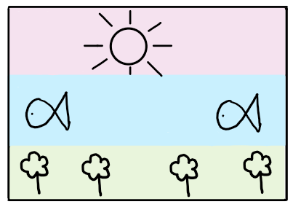

Preamble
We, the people of Jessiana, promise to uphold the values of this community as written in the following constitution. We pledge to unite as a one to ensure that Jessiana is a society where everyone is welcome and included. Collaboration is a major of our community because to us, being a team means that everyone is involved and has a part in our land. As a united nation, we are going to encompass all individuals with kindness and generosity whilst embracing each other's unique talents and differences.

Parliament and Government
Jessiana has a representative democracy, to us, this means that representatives and prime minister, will represent the people of our community. We have three levels of government federal, state, and local. There will be a representative in every five suburbs that will sort out some minor problems for the area. If you are between the ages of 18 and 85, voting is essential for you to be considered an active citizen. Nevertheless, if you do not vote you will be fined. Under 18's are not allowed to vote and members over 85 have a choice if they want to vote. The voting forms will be personally sent to you by mail which stops the crowd chaos. People may go for a representative position during a vote if they meet the following requirements:

- Over the age of 18
- Educated
- No criminal record
- Must be a citizen of Jessiana
- Maintain a good understanding of how the government is run

Rights of all citizens
These are some of the various rights for our citizens:

- Freedom of speech
- Right to choose your favored representative/prime minister
- Free healthcare
- Quality education
- Clean water
- Adequate housing
- Food (enough to keep you healthy)

Responsibilities of all Citizens
The citizens of Jessiana are expected to uphold the values and virtues of our community and should treat each other with respect and integrity. Citizens between the ages of 18 and 85 are expected to be active within the community and to vote at elections. They are also expected to maintain a peaceful environment with other people. Everyone (permanent residents or visiting) are expected to abide by the law as set by the government. Other essential responsibilities may include:

- Access to government help (such as free food, healthcare etc.) you will need to complete a form that will be inspected by your local government before these are accessible for you.
- You must be a citizen to be able to obtain the form.
- Not to exploit government support.
- Stay engaged in current political events.
- To withhold a safe environment towards other people.
- See all people of all ages, races, disabilities, gender, and religious belief as equal.
- Responsible consumption of day to day items.
- Citizen within the ages of 12 and 45 are expected to complete at a minimum of 1 hour of community service a week.

Responsibilities of Leaders:
Having 3 levels of government is going to let as more people have a chance to have a choice for what they want and what they think is right. The three levels of government are federal, state, and local.

Federal government:
- Lead the country.
- Decision making in foreign affairs.
- Deciding when the voting will commence.
- Noting possible amendments of the constitution.
- Preservation of nature and wildlife.
- Funding schools, hospitals etc.
- Create an efficient community

State government:
- Building of schools
- Building of hospitals
- Planning of parks
- Roads and streets
- Maintenance of public transport
- Agriculture

Local Government:
- Homeless shelter and people
- Shops and small businesses
- Maintenance of parks
Citizen participation
The citizens of Jessiana are always expected to be active within the community. Ways that they could do this include:

- Voting at elections.
- Utilizing the great education at schools.
- Holding a job within the community.
- Helping at social events.
- Supporting local producers by shopping at the farmers’ market.
- Learn about politics
- Help at community events

Amendments of the Constitution
Once an amendment of Jessiana's constitution is proposed it is passed through the parliament house (Federal, state, and local.) Once the whole of them have agreed that the change in the Constitution would make our community flow smoother, then it will be published to the citizens. Once the amendment has been published, the people have a right to vote. (the same rules follow as when you vote for the prime minister.) then the whole of Jessiana will have a referendum, and the people will vote yes or no to decide if they want that to be amended. Half of Jessiana's suburbs must vote yes for it to be amended. The constitution may not be changed more than once every two years.

Signed by:

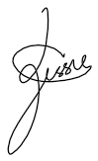
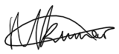
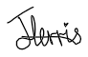

Jessie Lau Mariana Kumar Jess Ferris

