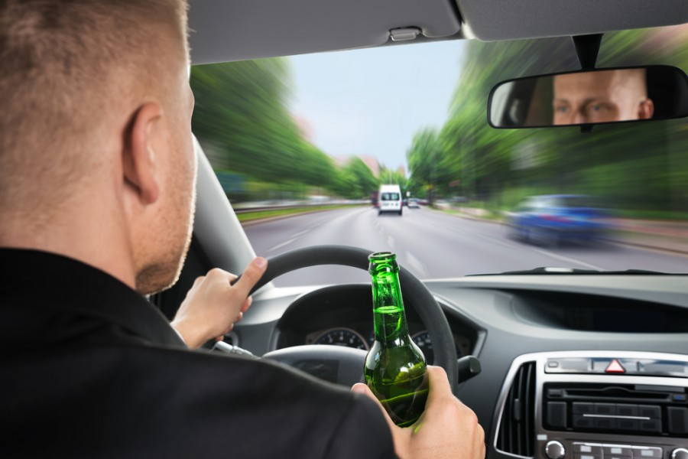

DRINK DRIVING COMES WITH GREAT RISKS FOR YOU AND OTHER DRIVERS ON THE ROAD. DO EVERYONE A FAVOUR AND TAKE A CAB

THINK BEFORE YOU DRINK.